Precipitation measurements at Rothera research station in Antarctica
Steven Colwell

Measuring precipitation in the Antarctic is very difficult and at present no reliable way of ground truthing the data exists. At the British Antarctic Survey’s Rothera station on the Antarctic Peninsula at (67.5S, 68.1W) we are trialling a selecting of precipitation gauges to assess which is the most accurate.

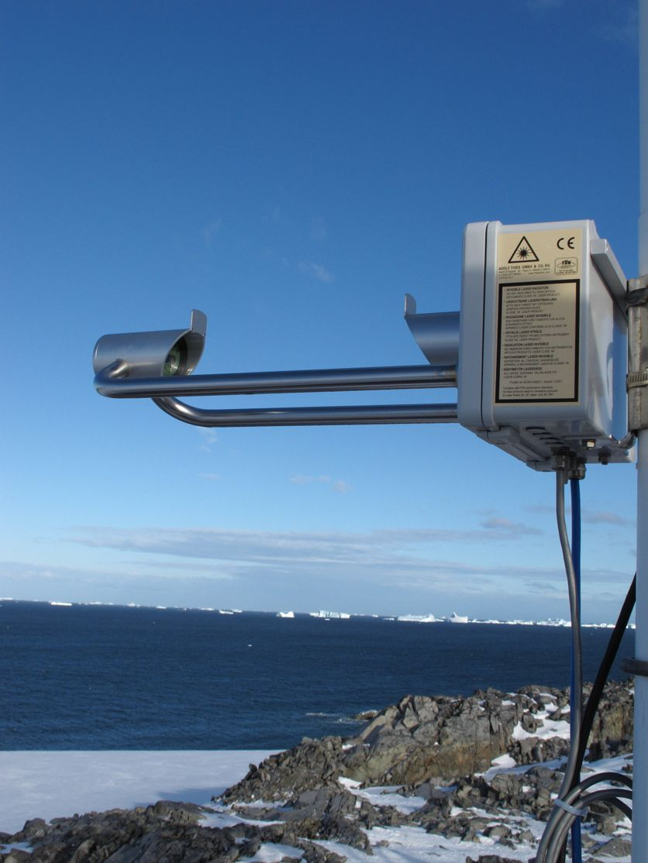
The first sensor that we have is a Thies Laser Precipitation Monitor (LPM) and this uses an infra-red laser to measure water droplets and snow that pass between its sensor heads. It measures the reduction in the received signal and the length of time of the reduction and from this it can calculate the diameter of the particle and the fall speed, additional information can be found at http://www.biral.com/met/precipitation/lpm.htm

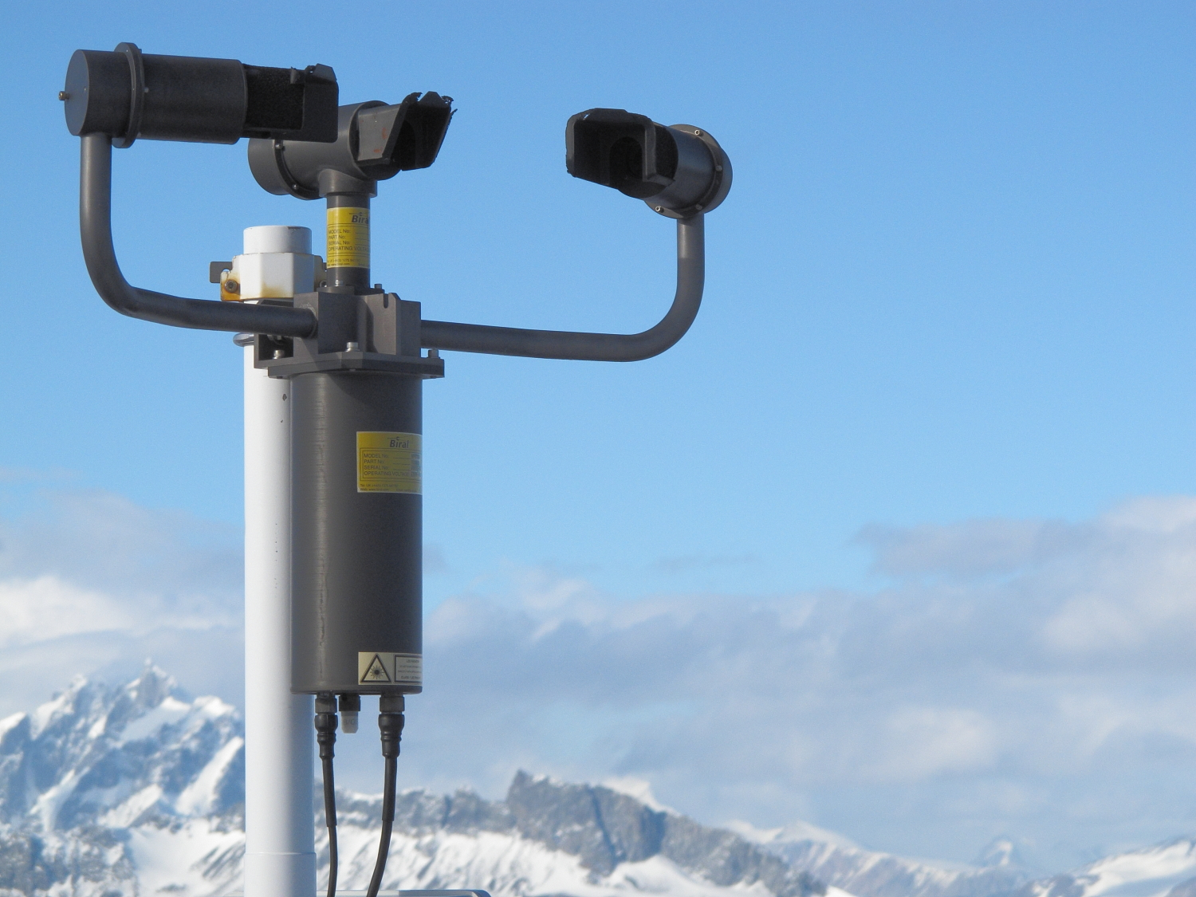
Alongside this is a Biral VPF 730 combined precipitation and visibility sensor that operates using an infrared beam and looking at off axis scatter to calculate visibility and looking at backscatter to calculate precipitation type and intensity. Additional information about the VPF 730 can be found at
http://www.biral.com/meteorological-sensors/visibility-and-present-weather/hss-vpf-730-visibility-and-present-weather-sensor

The final optical sensor that we have is a Campbell Scientific PWS100 and consists of a Digital Signal Processor (DSP) housing unit connected to a sensor arm that contains one laser head and two sensor heads. Each sensor head is 20° off axis to the laser unit axis—one in the horizontal plane and the other in the vertical plane. From the measurements taken it then uses fuzzy logic to calculate precipitation type and intensity. Additional information can be found at http://www.campbellsci.com/pws100

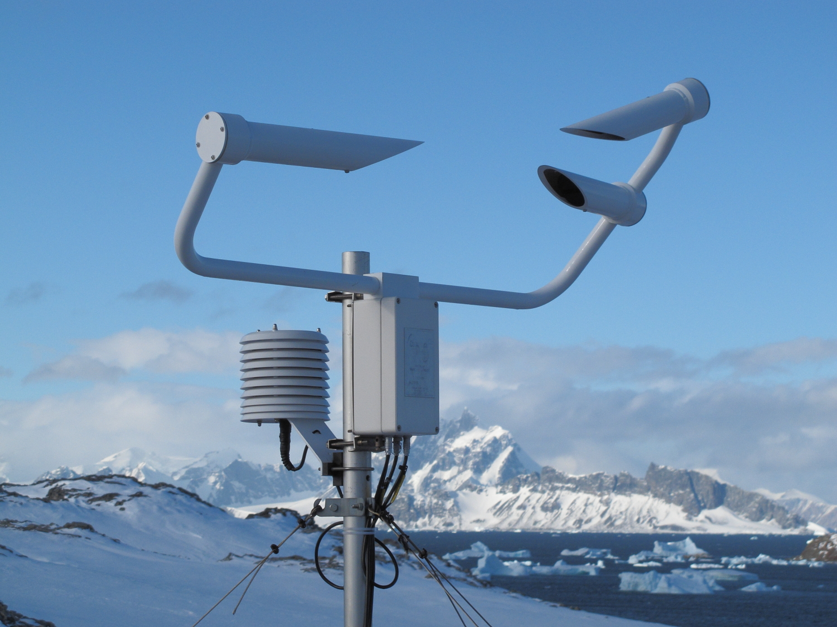
There is also a UPG1000 - Universal Precipitation Gauge snow gauge that is made by Environmental Measurements Ltd (EML). This is surrounded by a wind shield and when snow falls into the gauge it is melted and then measured using a tipping bucket, pictures can be seen below and additional information can be found at
http://www.emltd.net/products/precipitation/upg1000-universal-precipitation-gauge

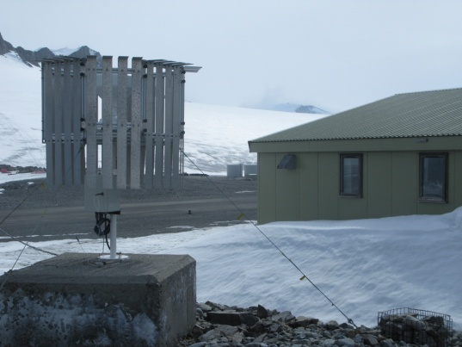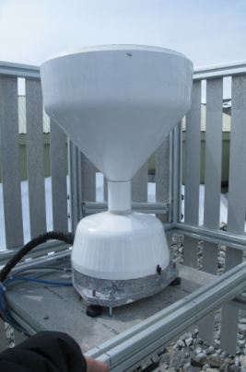

Initial results show a large difference between all of the gauges on a monthly scale but in low wind speed conditions there is close agreement between all of the sensors. More analysis of the data are being carried out to try and ascertain which of them is most accurate for use in the Antarctic.

This presentation will look in more detail at the operation of the sensors and how the data compares in different wind regimes.

